CO2 - ASSESSMENT 1: REPORT ANALYSIS
Course Faculty | : | Dr. K. Anbazhagan
Course Name | : | Ethical Hacking
Course Code | : | ITA1406
Slot | : | Slot B
Total Marks | : | 100
Name | : | G Siva Sai Kumar Reddy
Register Number | : | 192411180
Code of Conduct:
I, G. Siva Sai Kumar Reddy (192411180), certify that this submission is my original work and that I have adhered to the guidelines specified for this assessment. I understand that any violation of academic integrity rules will result in disciplinary action.
Signature of the student: Siva Sai
Domain & Email Footprinting using theHarvester
Domain Name: saveetha.com
Step 1: Install Python
- Open https://www.python.org/downloads/
- Download the latest Python version.
- Run the installer.
- Tick Add Python to PATH
- Click Install Now
Step 2: Verify Python Installation
- Press Windows + R
- Type cmd and press Enter
- Run: python -m pip install --upgrade pip
Step 4: Install theHarvester
- Run: pip install theHarvester
- Run: python -m pip install theHarvester
- Wait until the installation finishes.
Step 5: Verify theHarvester
- Run: theHarvester --help
Step 6: Run theHarvester
- Run: theHarvester -d saveetha.com -b all
Step 7: Wait for the Results
- theHarvester displays Email Addresses, Subdomains, Host Names and IP Addresses.
Results (from theHarvester output)
Emails found (list all one by one)
ILLUSTRATIVE FORMAT ONLY · replace with results from your own run.
- [email address returned by theHarvester]
- [email address returned by theHarvester]
If no emails appear, write: No email addresses found.
Sub emails found (list all one by one)
ILLUSTRATIVE FORMAT ONLY · use only subdomains actually listed.
- [subdomain.saveetha.com returned by the tool]
- [another subdomain returned by the tool] If none appear, write: No subdomains found.
Hosts and Its IP (list all one by one)
ILLUSTRATIVE FORMAT ONLY · do not copy made-up host/IP values.
- [hostname returned by the tool] · [matching IP address]
- [hostname returned by the tool] · [matching IP address]
- [hostname returned by the tool] · [matching IP address] List each host/IP pair shown in your actual output.
Total Email Addresses Found | Enter actual count
Total Subdomains Found | Enter actual count
Total Hosts Found | Enter actual count
Total IP Addresses Found | Enter actual count

Screenshot of Command execution
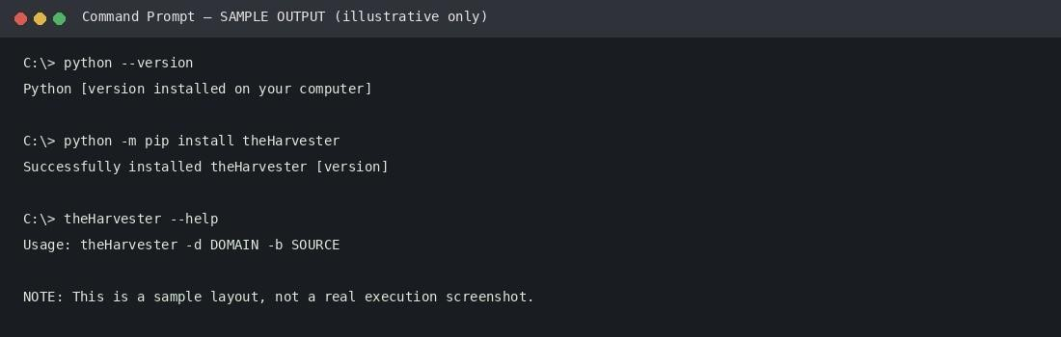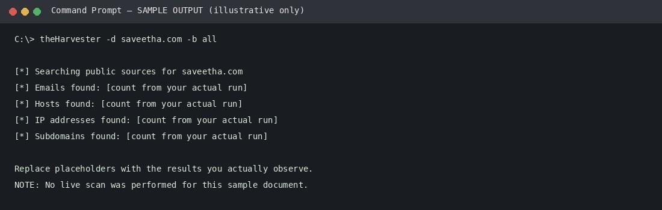

Screenshot of theHarvester output

Analysis and Interpretation
Emails: Email addresses show the naming format used by the organization (for example name@domain). An attacker can use this format to guess other staff addresses and send targeted phishing messages.
Subdomains and hosts: Each subdomain points to a separate service such as a portal, mail server or test site. Forgotten or test subdomains are often less protected and expand the attack surface.
IP addresses: IP addresses show where the services are hosted. They help map the network, identify hosting providers and choose systems for later scanning, with permission.
Security significance: All of this data is public, so it was gathered passively without touching the organization's systems. It shows how much information about an organization can be found from open sources, which attackers use for the reconnaissance phase.
Countermeasures: Limit staff emails published online, use generic role addresses, remove unused subdomains, keep DNS records clean, enable multi-factor authentication, and train staff to spot phishing.

